H.T No
Regulations:
A19

Sreenidhi Institute of Science and Technology
(An Autonomous Institution)
Code No: 7U101 Date: 29-April-2022 (FN)

M.Tech I-Year I-Semester External Examination, April/May - 2022 (Regular/Supplementary)
DIGITAL SYSTEM DESIGN (DSCE)

Time: 3 Hours Max.Marks:70

Note: a) No additional answer sheets will be provided.
b) All sub-parts of a question must be answered at one place only, otherwise it will not be valued.
c) Missing data can be assumed suitably.

ANSWER ANY FIVE QUESTIONS. EACH QUESTION CARRIES 14 MARKS.

Bloom's Cognitive Levels of Learning (BCLL)
Remember | L1 | Apply | L3 | Evaluate | L5
Understand | L2 | Analyze | L4 | Create | L6

 |  |  | BCLL | CO(s) | Marks
1. | a) | Design parallel divider for dividing a positive 5-bit binary number by 3-bit positive number using dividend register, divisor register, subtractor-comparator and control block. | L6 | CO1 | [7M]
 | b) | Develop a SM block for 4-input variables (A, B, C, D), 5-output variables  (V, W, X, Y, Z) and 2-exit paths.  If A, B and C are '1’ then output V and Z is always ‘0’.  If C =1, D=0 and X=1 then exit path ‘1’ is taken.  If C =0, D=1 and Y=1 then exit path ‘2’ is taken. | L4 | CO1 | [7M]
2. | a) | Justify that for combinational circuits fault dominance is a transitive relation, ie. if f dominates g and g dominates h, then f dominates h. | L4 | CO2 | [7M]
 | b) | Find out the output function of the given circuits for the faults  (i) AND bridge between the input of gate G2  (ii) The multiple fault {x₃ s-a-1 x₂ s-a-0}  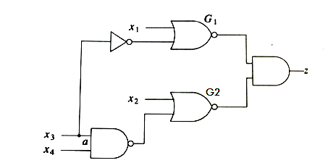 | L5 | CO2 | [7M]
3. | a) | Explain about the transition count testing. | L2 | CO3 | [7M]
 | b) | Compare feedback bridging and non feedback bridging fault with examples . | L4 | CO3 | [7M]
4. | a) | Show that to improve the fault resolution of a given test set T, it is necessary to generate tests to distinguish among faults equivalent under T . | L3 | CO4 | [7M]
 | b) | Compare Circuit test and transition check approach of fault diagnosis in sequential circuits. | L4 | CO4 | [7M]
5. | a) | How can autonomously testable PLA test the fields automatically? | L2 | CO5 | [7M]
 | b) | What are the facts about the PLA’s used for concurrent error detection by a series of checkers? Explain with an example. | L3 | CO5 | [7M]
6. | a) | Determine the reduced state table of the following state table  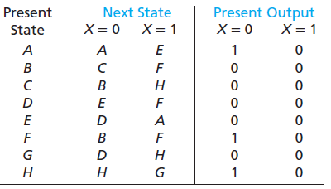 | L5 | CO6 | [7M]
 | b) | For an 16-state sequential circuit using 4 flip-flops , give 4-state assignments that assign 0000 to S0 and are equivalent to a straight binary assignment. | L3 | CO6 | [7M]
7. | a) | Develop a SM chart for binary multiplier. | L4 | CO1 | [5M]
 | b) | How can a fault f be said to be detectable? | L2 | CO2 | [5M]
 | c) | Compare exhaustive and pseudo random testing. | L4 | CO3 | [4M]
8. | a) | List out various fault diagnosis approaches in sequential circuits. | L1 | CO4 | [5M]
 | b) | Justify that PLA minimization leads to area reduction. | L5 | CO5 | [5M]
 | c) | How can the hazards be considered in the minimization and transformation of sequential circuits? | L2 | CO6 | [4M]

-- 00 -- 00 –

